Sequence of steps to be followed for undertaking consultancy projects

* * *

- The expression of Interest received directly or through the Institute is to be examined by the prospective consultant and interaction may be made with the client if necessary for clarification.

- Final consultancy proposal including the scope of work of both the consultant and the client as well as the budget including Institutional charges, GST and other taxes as applicable needs to be submitted through HoS to the Dean (SRIC) office along with the endorsement format#1, duly filled in by the consultant, for endorsement

- The final proposal may be forwarded to the client by the consultant/ SRIC Section as the case may be.

- After receiving the sanction letter from the client, agreement#2 in the prescribed format needs to be signed by both the parties i.e. client & consultant with the counter signature of the Dean (SRIC)

- Invoice will be prepared by the SRIC Section on request of the consultant for payment of advance by the client and be sent to the client by the Consultant/SRIC Section.

- After the payment is received by the SRIC Section; the consultancy project form#3 along with the copy of sanction letter and final proposal needs to be submitted by the consultant to the SRIC Section for examination and allotment of project code.

- The consultancy project is to be executed by the consultant as per the agreement. The final report of the consultancy project, after execution, would be submitted by Consultant in-charge either through SRIC Section or directly to client with a copy to SRIC Section.

- On submission of the completion report to the client, the consultancy fee would be paid to the Consultant/Co-Consultant as per rule after deducting Institutional Charges, GST and TDS as applicable, after the approval of the competent authority.

Note:

#1 Endorsement Format – to be submitted along with proposal as mentioned at step 2 #2 Agreement – to be submitted on receipt of sanction order as mentioned at step 4
#3 Consultancy Project Form – to be submitted on receipt of fund as mentioned at step 6

CALCULATION OF CONSULTANCY FEE

Sl.  No. | Type of Consultancy | Rate or overhead  ( after deduction of GST )
1. | Use of no Institute Facilities | 25%
2. | Use of Institute facilities such as Computer, Network, Space etc. | 30%
3. | Primarily testing and interpretation including laboratory | 35%

If project cost after deduction of GST ( Prior to overheads) is X; then overheads of p% will be charged on X as per the table, GST will be as applicable on (X + p% overheads). For example, for a project cost of X = 100 and 30% overheads, the calculation is as follows:

Project Cost = Rs. 100.00
Overhead = Rs. 30.00

GST = (Rs. 100.00 + Rs. 30.00) x (18%)= Rs. 23.40
Total Cost of the Project: Rs. 153.40

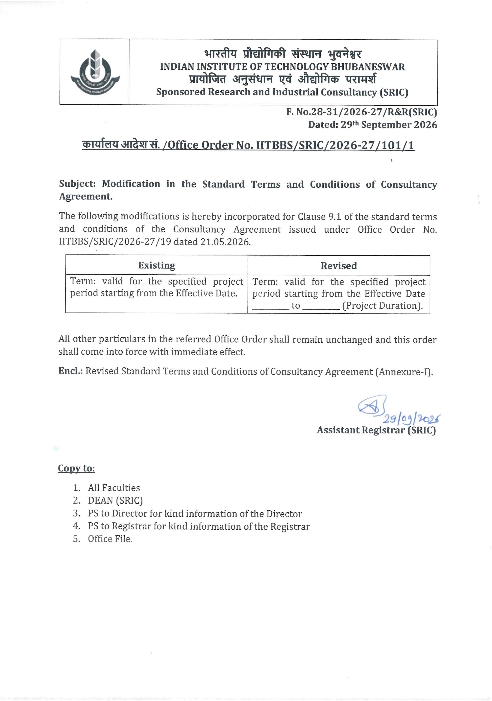
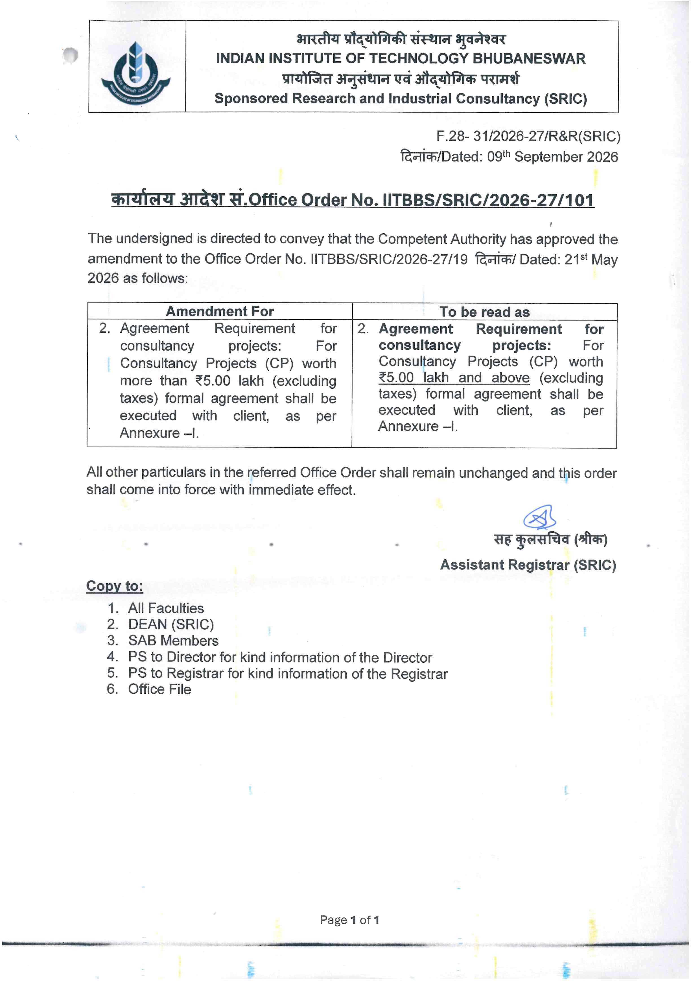
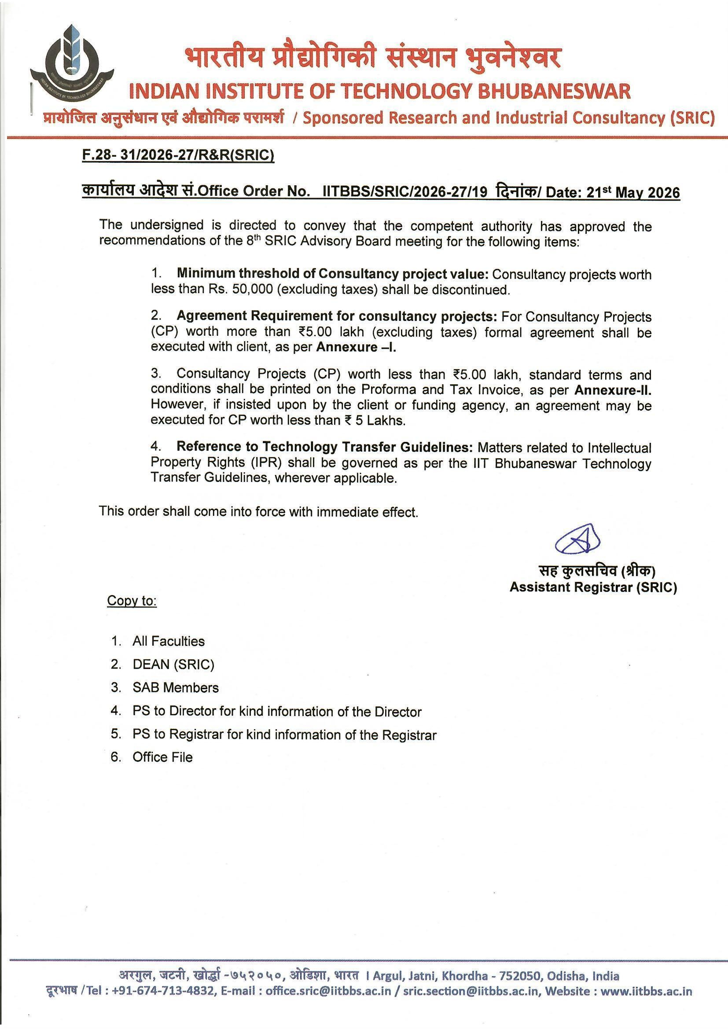

Annexure-I

STANDARD TERMS AND CONDITIONS OF CONTRACT FOR CONSULTANCY

Title of the Consultancy Project:

Name & Address of the Client:

Name and School/ Dept. of the Consultant In-charge:

CONSULTANCY AGREEMENT (CA)

This Consultancy Agreement ("CA") is made as of the ____[Day] day of [Month], 2026 ("Effective Date").

BY AND BETWEEN

IIT BHUBANESWAR a statutory body constituted under The Institutes of Technology Act 1961 with Amendments upto 2012, functioning at its premises at Argul, Khordha, Odisha, India-752050 represented by the, Dean SRIC duly authorized by the Director, IIT BHUBANESWAR hereinafter referred to as ‘INSTITUTE’ which expression shall where the context so admits includes its successors in interest and permitted assigns as First Party.
AND
ABCD, a Department or a Ministry or a Company/Registered Society/Proprietorship with GST No _________________[GST] having its registered office at ___________________________________________[Registered Office Address] and registered in India, represented by [Name] (hereinafter referred to as "ABCD") which expression shall where the context so admits includes its successors in interest and permitted assigns as Second Party.
"INSTITUTE" and "ABCD" will individually be referred to as a 'Party' and collectively as 'Parties'.
RECITALS:
WHEREAS:
- ABCD is in the business of ______________________________ [Description of ABCD's business].

- ABCD is interested to engage Prof./Dr. ……………… …………………..(a faulty of INSTITUTE ) as consultant for a consultancy work __________________________[Area of Consultancy project].

- Institute is a premier academic and research INSTITUTE established by the Government of India and has the expertise and facilities to carry out consultancy & R&D studies in the said area.
In consideration of the above recitals and the mutual benefits to derive hereafter, the Parties agreed to enter into an agreement as follows:

- Scope & Objective

  - ABCD & INSTITUTE agrees to work on __________________________________ (Area of Consultancy project /Problem Statement) ______________________________________________________ Scope of the consultancy work/research will remain limited to finding out__________________________.
  - INSTITUTE hereby agrees to carry out the Consultancy work to find a solution to the given problem statement in a timely manner in accordance with the terms of this CA subject to ABCD performing its reciprocal obligations hereunder as specified in the CA.

- Obligations & Responsibility of the Parties
5.1. ABCD:
5.1.1 ABCD will provide instruction, data and materials in a timely manner to support the research.
5.1.2 ABCD shall make all due payments within 15 days of the raising of invoices CA.
5.1.3 GOODS AND SERVICES TAX: As Per GST Act 2017, the Goods and Services Tax will be levied on total consultancy charges and this amount is to be borne by the ABCD.
5.1.4 ________________ [Additional obligation of ABCD].
5.2. INSTITUTE:
5.2.1 All work undertaken by the Principal Investigator (PI)/Co-Principal Investigator (Co-PI) at INSTITUTE as part of the project will be in good faith and based on material/data/other relevant information given by the ABCD requesting for the work. ABCD will provide the details of project already executed/ongoing by different PIs of INSTITUTE and will give an undertaking that the project under consideration has not been executed by any other PI of any other department in INSTITUTE.
5.2.2 SUB-CONTRACTING: The Institute reserves the right to allow any work in connection with the project, experimental or otherwise, to be carried out by a third party as per Institute norms and procedures, provided that the Institute takes necessary steps to prevent disclosure of information.
5.2.3 The INSTITUTE through PI/Co-PI undertakes to carry out the project as conscientiously as conditions allow, but accepts no economic responsibility whatsoever, should the work not lead to expected results. INSTITUTE shall not be held liable for any loss, damage, delay or failure of performance, resulting directly or indirectly from any cause, which is beyond its reasonable control (Force Majeure).
5.2.4 The report on the consultancy project is the technical opinion of the PI/Co-PI based on his/their expertise in the particular area of research and in no way reflects the view(s) of the INSTITUTE. The INSTITUTE is not responsible for the
accuracy or completeness of the report and the role of the INSTITUTE is limited to providing administrative support to the project.
5.2.5 Limitation of Liability: Gross total Liability of the INSTITUTE under this agreement under any circumstance shall not exceed ₹ 50,000/-.
5.2.6 At the end of the project, a final report ("Deliverables") will be presented to ABCD together with a know-how transfer, if applicable.
- Funding & Payment
  - The ABCD shall pay to INSTITUTE ₹_________ (Rupees in words_________________) ("Project Fund") for the execution of the project. Applicable taxes shall be borne by ABCD and shall be paid in addition to the agreed project fund.
  - Payments will be made by ABCD within 15 days of raising the invoice.
  - Instruments and/or equipment obtained in connection with the project and charged to the ABCD remain the property of the INSTITUTE, unless otherwise it is specifically agreed to by the Institute.
  - All payments by ABCD shall be made in the name of The DEAN SRIC IIT Bhubaneswar. GST will be added as applicable. INSTITUTE may be exempt for TDS.
- Ownership of Intellectual Property (IP):
Any IP developed during the project, the detailed Terms and Conditions regarding transferring/assigning/selling/commercialising these IP rights to the ABCD/Client shall be governed by a separate written agreement as per Intellectual Property (IP) guidelines of the Institute.

- Confidentiality Obligation
Each Party shall keep all proprietary information confidential and not use for any purpose not contemplated hereunder disclosed by the other Party, directly or indirectly. Any discoveries, inventions or know-how resulting from the project shall be kept confidentially for a period of three (3) years from the date of termination of this CA, except as authorized in writing by other Party or provided herein.

All information protected under this clause should be in writing.

- Duration and Termination
  - Term: Valid for the specified project period starting from the Effective Date_______________ to_______________(project Duration).
  - Termination:
    - Mutual: Both parties can agree to end the CA early after settling accounts.
    - Convenience: Either party (ABCD or INSTITUTE) can terminate for any reason with 30 days' written notice.
    - Payment: ABCD must pay INSTITUTE for all work performed, expenses incurred, or firm orders placed up to the termination date.

- Survival: Confidentiality, IP rights, and dispute resolution clauses remain in effect even after the CA ends.
- Miscellaneous Provisions
  - Notices: Must be in writing (personal delivery and/or official email) with effective date of delivery.
  - Force Majeure: Neither party is liable for delays caused by uncontrollable events (Acts of God, strikes, pandemics, etc.). A 14-day notice is required to request a time extension.
  - Assignment & Branding: No transferring the agreement to others, and no use of the other party’s name/logo without written consent.
  - Entire Agreement: This document supersedes all previous discussions and other forms of communication.
- Dispute Resolution
  - Settlement: Parties must attempt to settle the dispute amicably within 45 days of notice of dispute send by one party to the other through good faith negotiations.
  - Arbitration: If unresolved, disputes go to a single arbitrator under the Arbitration and Conciliation Act 1996.
  - Jurisdiction: Legal proceedings will be in English, held in Bhubaneswar, and governed by Indian Law.
In Witness thereof the Parties have executed the CA on Effective Date as mentioned in first page.

INSTITUTE  Signature:  Name: Prof. [Name]  Title: Dean, SRIC | ABCD  Signature:  Name: [Name]  Title: [Title]
Confirming Party  Signature:  Name:  Title: PI from INSTITUTE | Witness  Signature  Name:  Title:
(with office seal) (with office seal)

Annexure – II
STANDARD TERMS AND CONDITIONS FOR CONSULTANCY Work (for Invoice)
1. IIT Bhubaneswar (hereinafter INSTITUTE) hereby agrees to carry out the Consultancy work to find a solution to the given problem statement in a timely manner in accordance with the following terms & conditions subject to client performing its reciprocal obligations hereunder.
2. CLIENT shall provide instruction, data and materials in a timely manner to support the research.
3. CLIENT shall make all due payments within 15 days of the raising of invoices.
4. GOODS AND SERVICES TAX: As Per GST Act 2017, the Goods and Services Tax will be levied on total consultancy charges and this amount is to be borne by the CLIENT.
5. All work undertaken by the Principal investigator (PI)/Co-Principal Investigator (Co-PI) at INSTITUTE as part of the project will be in good faith and based on material/data/other relevant information given by the CLIENT requesting for the work. CLIENT will provide the details of project already executed/ongoing by different PIs of INSTITUTE and will give an undertaking that the project under consideration has not been executed by any other PI of any other department in INSTITUTE.
6. Sub-Contracting: The Institute reserves the right to allow any work in connection with the project, experimental or otherwise, to be carried out by a third party as per Institute norms and procedures, provided this does not result in the danger of information of a confidential nature coming into the hands of unauthorized persons.
7. The INSTITUTE through PI/Co-PI undertakes to carry out the project as conscientiously as conditions allow, but accepts no economic responsibility whatsoever, should the work not lead to expected results. INSTITUTE shall not be held liable for any loss, damage, delay or failure of performance, resulting directly or indirectly from any cause, which is beyond its reasonable control (Force Majeure).
8. The report on the consultant project is the technical opinion of the PI/Co-PI based on his/their expertise in the particular area of research and in no way reflects the view(s) of the INSTITUTE. The INSTITUTE is not responsible for the accuracy or completeness of the report and the role of the Institute is limited to providing administrative support to the project.
9. Limitation of Liability: Gross total Liability of the INSTITUTE under this agreement under any circumstance shall not exceed ₹ 50,000/-.
10. At the end of the project, a final report ("Deliverables") will be presented to CLIENT together with a know-how transfer, if applicable.
11. Funding & Payment:
11.1 The CLIENT shall pay to INSTITUTE agreed amount (“Project Fund”) for the execution of the project. Applicable taxes shall be borne by CLIENT and shall be paid in addition to the agreed project fund.
11.2 Payments will be made by CLIENT within 15 days of raising the invoice.
11.3 Instruments and/or equipment obtained in connection with the project and charged to the CLIENT will remain the property of the INSTITUTE, unless otherwise it is specifically agreed by the Institute.
11.4 All payments by CLIENT shall be made in the name of The DEAN SRIC IIT Bhubaneswar. GST will be added as applicable. INSTITUTE may be exempted from TDS.
12. Ownership of Intellectual Property (IP): Per Developed during the project, the detailed Terms and Conditions regarding transferring/assigning/commercialising these IP rights to the ABCD/Client shall be governed by a separate written agreement as per Intellectual Property (IP) guidelines of the Institute.
13. Confidentiality Obligation: Each Party shall keep confidential and not use for any purpose not contemplated hereunder all proprietary information disclosed by the other Party, directly or indirectly. Any discoveries, inventions or know-how resulting from the project shall be kept confidentially for a period of three (3) years from the date of termination of this consultancy work, except as authorized in writing by other Party or provided herein.
14. Duration Term: Valid for the specified project period starting from the Effective Date i.e. receipt of project fund.
15. Termination:
15.1 Mutual: Both parties can agree to end this consultancy work early after settling accounts.
15.1.2 Convenience: Either party (CLIENT or INSTITUTE) can terminate for any reason with 30 days' written notice.
15.1.3 Payment: CLIENT must pay INSTITUTE for all work performed, expenses incurred, or firm orders placed up to the termination date.
16. Notices: Must be in writing (personal delivery and/or email) with effective date of delivery.
17. Force Majeure: Neither party is liable for delays caused by uncontrollable events (Acts of God, strikes, pandemics, etc.). A 14-day notice is required to request an extension.
18. Assignment & Branding: No transferring the agreement to others, and no use of the other party’s name/logo without written consent.
19. This document supersedes all previous discussions and other forms of communication.
20. Dispute Resolution:
20.1 Settlement: Parties must attempt to settle the dispute amicably within 45 days of notice of dispute send by one party to the other through good faith negotiations.
20.2 Arbitration: If unresolved, disputes go to a single arbitrator under the Arbitration and Conciliation Act 1996.
20.3 Jurisdiction: Legal proceedings will be in English, held in Bhubaneswar, and governed by Indian Law.

